尊敬的家长，

本周内容：

- 复习：结合新字“山”的学习，通过谈论山上山下山里有什么，复习学过的相关字词。详见图片：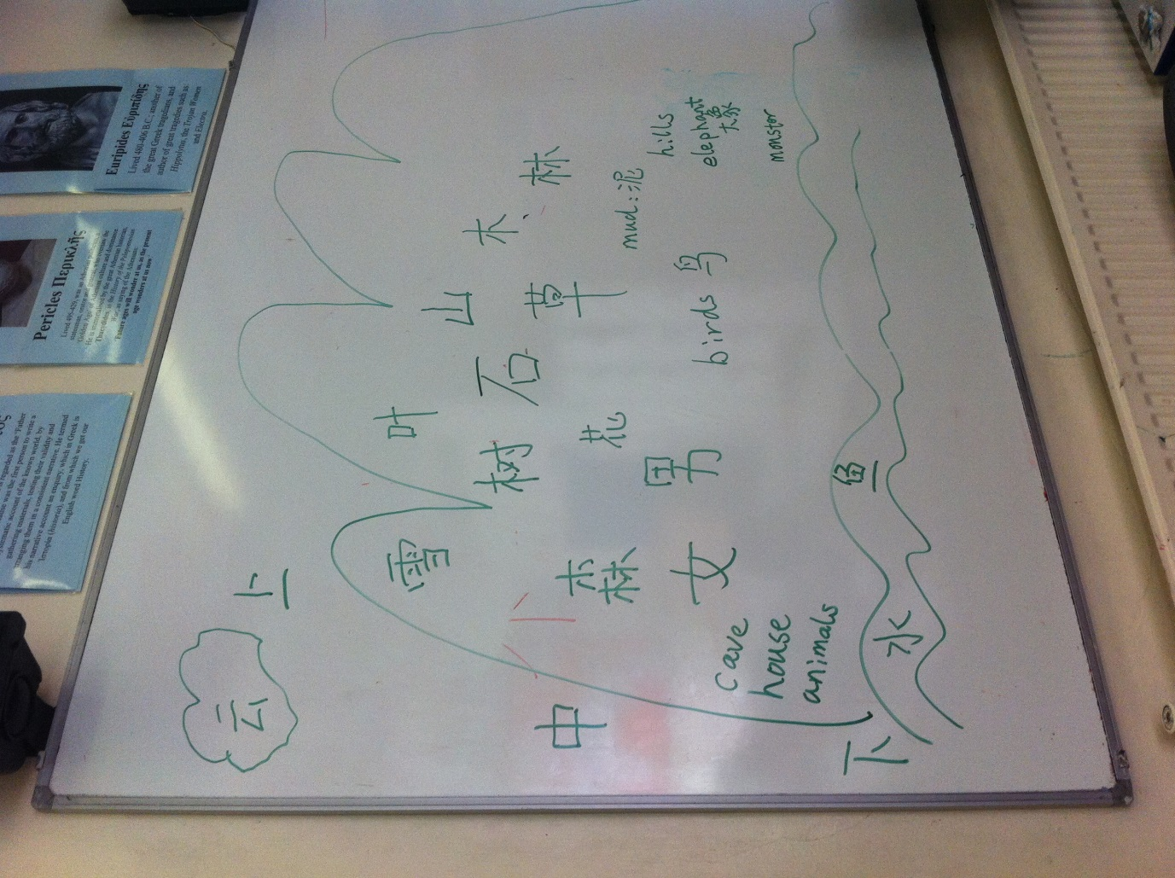。
2，学习新字：山shān, (mountain), 石shí (stone) 火huŏ (fire) 。理解“木”“火”“水”三行之间的关系。

3，练习对话。山上面、下面、中有什么？火怕水，水灭火，木怕火，木可以浮在水上。等等。
4，课堂作业：因为今天复习时间长，所以课堂作业为简单涂色。
今天的卡通：汉字：云， 山，月，水；汉字：石；希望这些卡通，让孩子真心觉得“汉字好好玩”。
注意：1) 今天的邮件学校网站已有。2)希望家长督促孩子在家里做适当的书写练习和口语对话。
推荐：很多孩子家里缺少汉语环境，如果能坚持让孩子每天看10分钟中文卡通或许能弥补。Youtube有很多汉字学习资源，推荐巧虎系列、粉红猪（Peppy Pig）系列和查理&劳拉(Charlie & Laura)系列，关键字检索即可搜到。
谢谢。下周再见。

白老师

Dear Parents,
This time we did:
1, Revise: By talking about what is on/under/in the mountain, review and talk the relative words. See image below FYI.
2, New word: 山shān, (mountain), 石shí (stone) 火huŏ (fire) 。Understand the relationship of “Wood”“fire”“water”, three elements of the “Five Elements”, the traditional Chinese cultural concept.
3) Dialogues: By talking about the Mountain, we created a series talking, including “Does Fire likes water or wood”, also funny talks “I find river on the top of the mountain” to which the kids judged and laughed. Where can we see stones?
4) Work: Simple coloring work as we spent long time revising and only have limited 15 minutes to do it.
Videos: 汉字：云， 山，月，水；汉字：石。 hope these video can let our kids feel that Chinese is FUN.
Recommendation: Most of our families do not speak Mandarin at home. To create a speaking & talking opportunities at home, I would suggest that the children spend 10 minutes every day to watch a short video/cartoon at home.
On YouTube, you can find the Chinese versions of “Charlie & Laura”, “Peppy Pig”, and also a series called “Qiaohu”, please search by the key words in Chinese: “查理”，”粉红猪”，”巧虎” respectively, you will be able to find them. Have Fun!
Please note: 1) you will find content of this email on school website. 2) Please help your child to practice Chinese writing which I have started to teach them before half term break.
Thanks. See you next week.

Ms Bai

